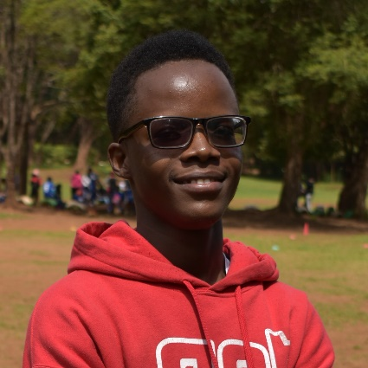

### Experience

09/2022 to current

**Frontend Web Development & Design**

**PERSONAL PROJECTS**, Ke

* Performed several freelance projects as well as over 50 personal projects with CSS, HTML, JS and SASS to build fully functional websites.
* Built Responsive websites at and modify employee schedules with service levels in mind.
* Ensure Cross Browser compatibility

09/2015 to 05/2019

**ODIN PROJECT -** FreeCodeCamp Academy

**Frontend Web Development**, Ke

* Performed and finished the program and passed. CSS, HTML, JS and SASS to build fully functional and Responsive websites

### Education

05/2022 to 05/2023

**CERTIFICATION IN FRONT END WEB DEVELOPMENT**

FreeCodeCamp Academy - 2022, **Int.**

**ONLINE COURSE IN RESPONSIVE WEB DESIGN**

FreeCodeCamp Academy - 2022, **Int.**

**THE ODIN PROJECT CERTIFICATION IN FRONT END WEB PROGRAMMING AND DEVELOPMENT**

FreeCodeCamp Academy – 2022, **Int.**

### Skills

* HTML/CSS
* JavaScript
* Frontend Frameworks e.g., React, Angular, Vue.js)
* Version Control/Git
* Responsive Design
* Web Performance Optimization
* Cross-Browser Compatibility
* API Integration
* Basic Back-End Knowledge

### Languages

* English
* Kiswahili

### Hobbies

* Creative Coding Projects
* UI/UX Design Exploration
* Blogging/Vlogging about Web Development
* Learning New Programming Languages
* Building Personal Web Projects
* Graphic Design
* Gaming for Problem-Solving
* Watching programming Movies

**Front-end Web Developer** equipped with extensive experience in building web applications and responsive user interfaces. Employs excellent problem-solving skills, fluidity and adaptivity to work with nearly any website. Demonstrated ability to improve web appearance and operations, and reduce costs. I seamlessly blend creativity with code to craft immersive digital experiences that captivate users, turning their interactions into memorable journeys that drive your brand's success

Austine Otieno

+254 (768) 927-617 [austine.oduk577@gmail.com](mailto:austine.oduk577@gmail.com)